

**NAME:**

**11AEMAM Test 5 2021**

**Section 1: /**

**Section 2: /**

**Total: /**

**%**

**TIME ALLOCATION FOR THIS TEST: 50 minutes**

**Section 1 – No Calculators Allowed.**

**minutes reading time: 2 minutes**

**minutes working time: 25 minutes**

**Section 2 – Calculators allowed**

**minutes reading time: 3 minutes**

**minutes working time: 20 minutes**

**Material required/recommended for this test**

**To be provided by the supervisor**

Question/answer booklets for Sections One and Two.

SCSA 11AEMAM Formulae Sheet

**To be provided by the candidate**

***Section One:***

Standard items: pens, pencils, pencil sharpener, highlighter, eraser, ruler

*Special materials: drawing instruments, templates, no notes, formula sheet*

**Section Two:**

Standard items: pens, pencils, pencil sharpener, highlighter, eraser, ruler

*Special materials: drawing instruments, templates, notes on a maximum of one unfolded sheet of A4 paper, double sided, up to three approved calculators, CAS, graphics, or scientific.*

**Important note to candidates**

No other items may be taken into the test room. It is **your** responsibility to ensure that you do not have any unauthorised notes or other items of a non-personal nature in the test room. If you have any unauthorised material with you, hand it to the teacher **before** reading any further.

|  |  |  |  |  |
| --- | --- | --- | --- | --- |
| **Section** | **Reading Time** | **Working time** | **Marks** | **Score** |
| **Resource free** | **2 minutes** | **25** | **27** | **%** |
| **Resource rich** | **3 minutes** | **20** | **20** | **%** |
| **Total** | **4 minutes** | **45** | **47** | **%** |

**Calculator Free Section: 25 minutes**

**QUESTION 1** [6 Marks: 2, 1, 1, 1, 1]

The spinners A and B are divided into 4 and 5 equal sectors respectively. They are spun at the same time and the numbers to which the arrows point are added.

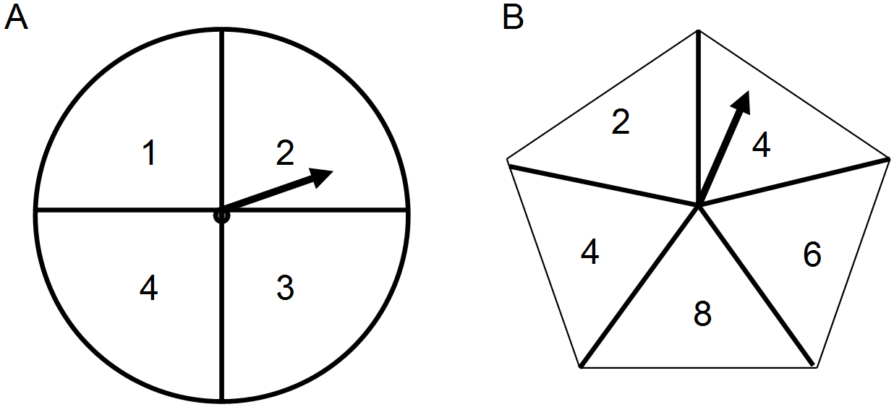

1. Use a suitable sample space to show all possible outcomes.
2. What is the probability that the total is even?
3. What is the probability that the total is 12?
4. What is the probability that the total is even given that the result on spinner A is an even number?

1. What is the probability that the total is at least 10 given that the total is greater than or equal to 7?

**QUESTION 2** [5 Marks: 3, 2]

Events *A, B* and *C* are such that *A* and *C* are independent.

The following probabilities are also known.

   and 

1. Show that events *A* and *B* are not mutually exclusive. (2 marks)
2. Determine  (3 marks)

**QUESTION 3** [3 marks: 1, 1, 1]

Students in Year 11 were surveyed to determine the number who had played competition sport and undertaken paid work the previous weekend. The results are provided in the table.

|  |  |  |  |  |
| --- | --- | --- | --- | --- |
|  | | Played competition sport | | |
| Yes | No | Total |
| Undertaken paid work | Yes | 54 | 11 | 65 |
| No | 50 | 25 |  |
| Total | 104 |  | 140 |

If a student is selected at random from this Year 11 group, what is the probability that:

(a) they played competition sport and undertook paid work?

(b) they either played competition sport or undertook paid work?

(c) they did not play competitive sport, given that they had undertaken paid work?

**QUESTION 4** [5 marks: 2,2,1]

Given , P(A) = 0.4 and P(B) = 0.5,

a) Find  (2)

b) Find P(A|B) (2)

c) Are events A and B independent? (Justify your answer) (1)

QUESTION 5 [7 marks: 2, 3, 2]

(a) Determine the number of possible combinations when five students must be chosen from a small class of seven. (2 marks)

(b) Determine the coefficient of the $x^{2}$ term in the expansion of

(i) ${\left(x+2\right)}^{3}$. (2 marks)

(ii) ${\left(3x-10\right)}^{7}$. (3 marks)

END OF CALCULATOR FREE SECTION

**Calculator Assumed Section** Name: …………………………………

Reading time: 3 minutes

Working time: 20 minutes Marks: 20

**QUESTION 6** [6 marks: 1, 1, 2, 2]

To qualify as an umpire, candidates had to pass both a written test and a practical test. Data from previous tests indicated that 90% of candidates passed the written test and of these 70% passed the practical test. Of those who failed the written test, 40% also failed the practical test.

(a) Represent this information on a tree diagram below.

(b) What percentage of candidates passed both tests?

(c) What percentage of candidates passed **at least** one test?

(d) Of those who did not qualify as an umpire what fraction of the candidates failed the written test?

**QUESTION 7** [6 marks: 3, 3]

For two events $M$ and $K$, $P\left(M\right)=0.4$ and $P\left(M \right|M∪K)=0.8$

Determine $P(K)$ if

(a) events $M$ and $K$ are mutually exclusive.

(b) events $M$ and $K$ are independent.

Question 8 [8 marks: 2, 2, 2, 2]

A chess club has $12$ members, of which $5$ are beginners, $3$ are intermediate and the rest are advanced. The club has to select a group of $4$ members at random to assist with a regional tournament.

(a) Determine the number of different groups that can be selected.

(b) Determine the number of different groups that can be selected which contain at least $3$ beginners.

(c) Determine the probability that the group contains

(i) no advanced members.

(ii) exactly one intermediate member.

END OF TEST